OSOC INDUCTIONS TASK

**Q1. Command for searching pattern line by line in any document with an example.**

Ans:- ‘grep’ is the command for searching a pattern line by line in a document.

Syntax: grep [options] pattern document

Eg:- **grep -n [^he] file.txt**

Here **‘–n’** is the option for checking pattern line by line

**‘[^he]’** is the pattern specifying line should start with ‘he’

**‘file.txt’** is the document name

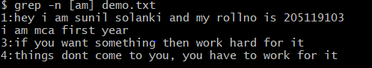

**Q2. What all permissions are there in Linux? State all permissions and different way of changing permissions with example**.

Ans:- There are three types of permissions

**Read(r)** -> to enable users to read the file

**Write(w)** ->to enable the users to write or make changes to file

**Execute(x)** ->to enable the users to execute the file

There are three types of users

**User**-> owner of the file

**Group**->group of the consumers

**Others**->other users

Ways to change the permissions:-

We can change the permission using ‘chmod’ command, ‘+ ’ is used for adding the permission, ’-’ is used for removing the permission and ‘=’ is used for assigning the permission sequence.

1.using 9 character long sequence of r,w,x.

2.using octal no.

To check the permissions of file

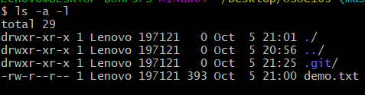

To change the permission of a file

Chmod ‘user_symbol_permission’ filename

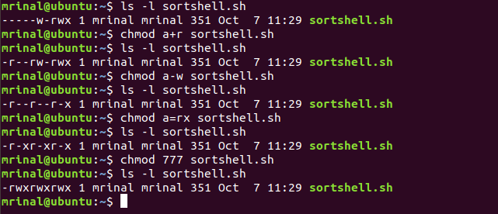

**Q3. Create a folder OSOC and inside that another folder Inductions and now create a file task.txt inside Inductions with some content now copy this file into another folder Workshop in OSOC.**

Ans:- **$mkdir OSOC**

**$cd OSOC**

**$mkdir Inductions**

$cat >task.txt

Hi this is the file of induction task of OSOC

$cpy Inductions/task.txt Workshop

**Q4. I want to check whether my system is connected to any network or not, please suggest appropriate command for this.**

Ans:- **$ ipconfig**

**Q5. I want to change password of another user how will I do that?**

Ans:- passwd username or sudo passwd username.

Eg:- passwd sunil

It will prompt for the current password and if you had given the right answer then it asks for new password checking its complexity.

**Q6. Using shell scripting write program for sort an Array. Input should be taken from user**.

Ans:- vi sortshell.sh

**#!/ bin / bash**

**echo Enter how many Elements**

**read n**

**echo "Enter array elements: "**

**for((i=0;i<n;i++))**

**do**

**read a[$i]**

**done**

**for((i=0;i<n;i++))**

**do**

**for((j=$i;j<n;j++))**

**do**

**if[{$a[$j]} -gt ${a[$j]}]**

**then**

**temp=${a[$i]}**

**a[$i]=a[$j]**

**a[$i]=temp**

**fi**

**done**

**done**

**}**

**echo "The sorted array is:"**

**for((i=0;i<n;i++))**

**do**

**echo${a[i]}**

**Done**

esc: w

esc: wq

chmod +x sortshell.sh

./sortshell.sh

**Q7. Using Shell scripting write a program to reverse a string. Input should be taken from user.**

Ans:- vi reverse.sh

**#!/ bin / bash**

**read -p "enter string to reverse" string**

**len=$**

**{**

**#string**

**}**

**for((i=$len-1;i>=0;i--))**

**do**

**reverse="$reverse${string:$i:1}"**

**done**

**echo "$reverse"**

esc: w

esc: wq

chmod +x reverse.sh

./reverse.sh

**Output:-**

enter the string ippississim

String after reverse is mississippi.

**Q8. What is the concept of Branching? How it is useful? Explain with working example.**

Ans:- Branches are pointers to a specific commit.

Branches are of two types:-

* Local Branches
* Remote-tracking branches.

There is always a master branch which contains all the codes. Suppose we want some changes but not sure to add to master branch or not, then we make another branch. Once we are sure to add those code we merge the local branch into master branch.

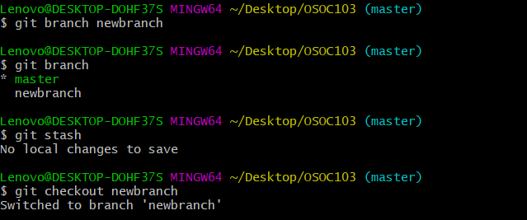

**Q9. What is Push, Pull and Commit? Explain with example**.

Ans:- **Commit:-** The git commit command captures a snapshot of the project's currently staged changes. Committed snapshots can be thought of as “safe” versions of a project—Git will never change them unless you explicitly ask it to. Prior to the execution of git commit, The git add command is used to promote or 'stage' changes to the project that will be stored in a commit.

**Push:-**The git push command is used to upload local repository content to a remote repository. Pushing is how you transfer commits from your local repository to a remote repo.



**Pull:-**The git pull command is used to fetch and download content from a remote repository and immediately update the local repository to match that content.

**General case**

Eg:- git pull ‘remote-address’ ‘branch-name’

**Local case**

Eg:- git pull

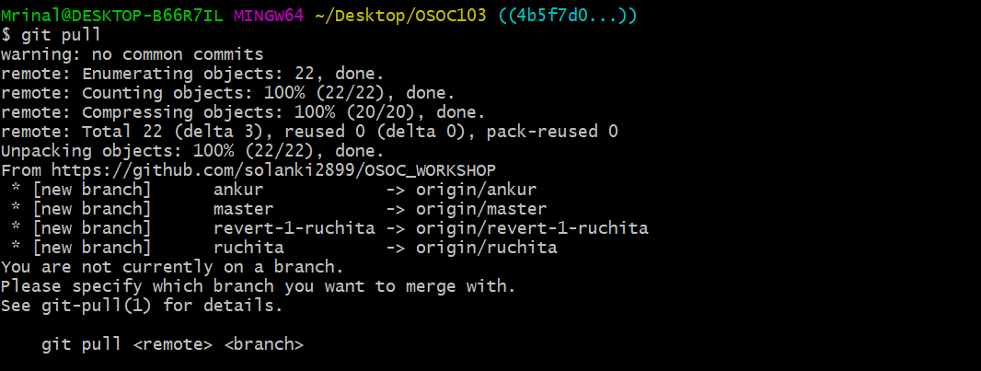

**Q10. Explain how we can restore a file after a commit with an Example.**

Ans:- we can restore a file to previous commits by using ‘checkout’, ’revert’ command

Syntax:- git checkout <commit_ID>

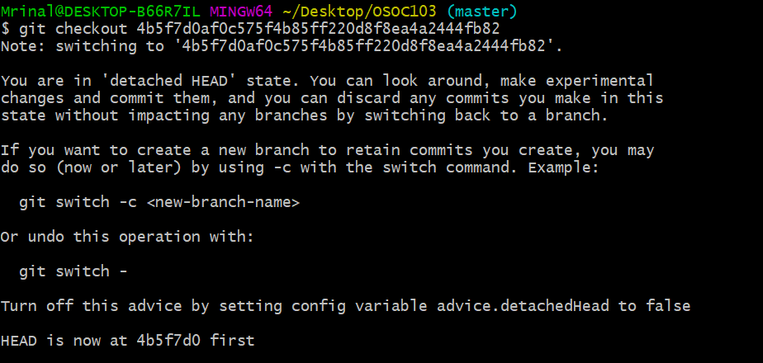

* git revert <commit_ID>

**Q11. How to preview the changes you have made before applying merging command? (write optimized command).**

Ans:- We can first update our local repository by using command

**$git fetch**

**$ git –va newbranch**

**Q12. How to apply any commits of current branch ahead of specified one? (write command with screenshot of command line).**

Ans:- $git commit

**Q13. what is stash stack? How to write working from top of stash stack? (write answer and show screenshot of command on command line).**

Ans:- Stashing : git stash temporarily shelves (or stashes) changes you've made to your working copy so you can work on something else, and then come back and re-apply them later on. Stashing is handy if you need to quickly switch context and work on something else, but you're mid-way through a code change and aren't quite ready to commit.

Command: git stash



To apply the stash

Command: git stash apply --‘stash index’[optional]

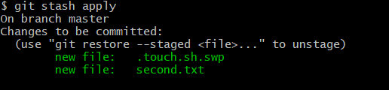

**Q14. How to show the commits on ex (branch Ankur) that are not on ex (branch Ruchita )? (write command with screenshot of command line).**

Ans:- **git log ‘branch name’**

